Akhan Arman Databases Lab work 1
Step 1: First of all, I listed all enrities and their atributies in my note.
Airports: airport id, airport name, country, state, city, when created, when updated
Flights: flight id, departing gate, arriving gate, when flight created, when updated, airline id, departure airport id, arrival airport id, scheduled departure time, scheduled arrival time, actual departure time, actual arrival time.
Airlines: airline id, airline code, name, country, when created and updated
Booking: booking id, flight id, status, booking platform, when booking is created and updated at, ticket price, and passenger id.
Boarding passes: boarding pass id, seat, boarding time, when created and updated,
and booking id.
Baggage: baggage id, weight in kg, created date, updated date, and booking id.
Baggage checking: baggage checking id, check results, created at and updated at, booking id, and passenger id.
Passenger information: passenger id, first name, last name, gender, date of birth, country of citizenship, country of residence, passport number, when profile is created at and updated at.
Security check: security check id, check results, when information created at and updated at, passenger id.

Step 2: After that I started to think about their relations.
One airport have many flights, flight have one arrival and one departure airport.
One airline have many flights, one flight have one airline.
One flight have many bookings, one booking belong to one flight.
One booking have many changes or zero, one change belong to one booking.
One each booking have one boarding pass.
One booking may have many baggages or zero, one baggage belong to one booking.
One booking can undergo many baggage checkings or zero if no baggage, one check belong to one booking
One passanger must have one booking or many, one booking belongs to one passanger.
One each passanger must undergo one Security check
One passanger may undergo many baggage check or zero(depending if they have baggage or not)
One baggage must undergo one baggage checking

Step 3: I opened draw.io web site as a tool to create a diagram.
I used Internal Storage to create boxes for entities and text to give them name and atributes.
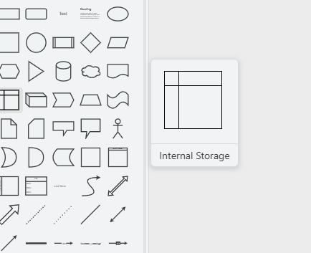
After that I used built-in entry relation page tools in order to create realations. (But some of them also required line tool for example one to many relarion)
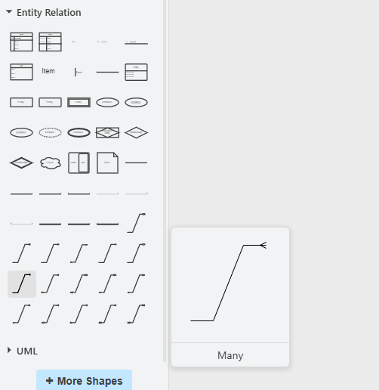
Step 4: I added legends and exported as a pdf file.
PS: I watched Lucid Software and Degan Kettles as an additional information sourse
